Geometry: Unit 1, Lesson 7

- What type of line segment does a rigid transformation result in?

A line segment that is congruent to the original line segment

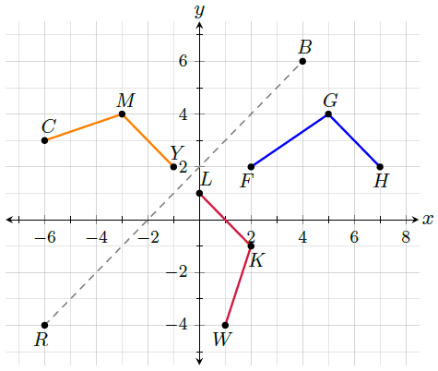
- A coordinate grid is shown with angles $∠FGH$, $∠CMY$, $∠WKL$ with line segment $\overline{RB}$. What has the same measure as angle $CMY$?

$$WKL$$
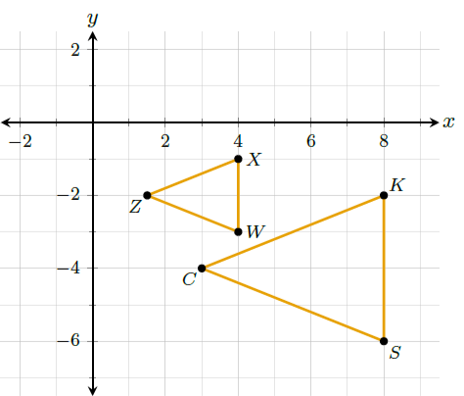
- Two triangles are shown where triangle $KSC$ is similar to triangle $XWZ$. Write a similarity statement between the two triangles.

$$\overline{SC}≅\overline{WZ}$$

